Step 1:

Login to your AWS account

Step 2:

Search Lambda In the Search Bar

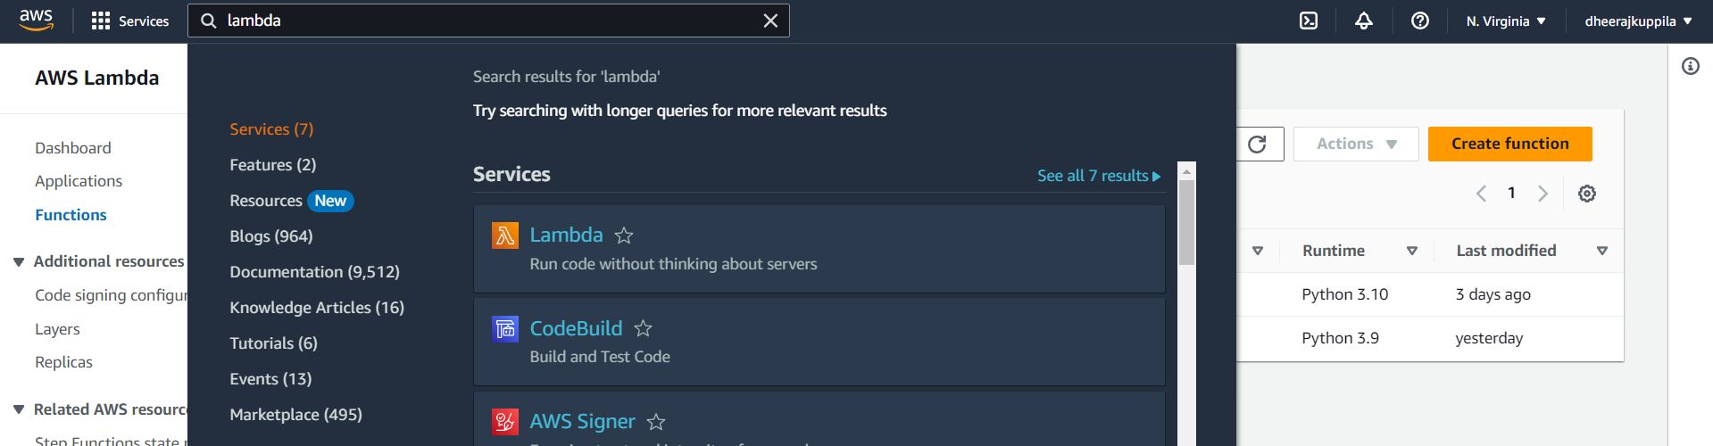

Step 3:

Click Create Function 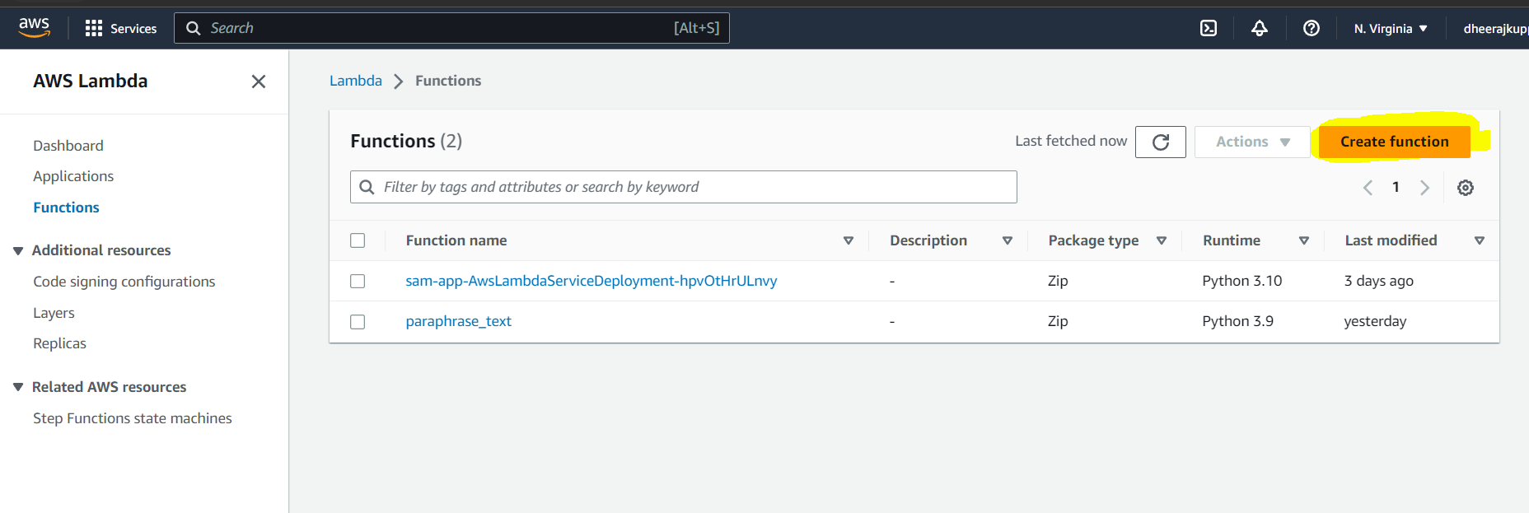

Step 4:

Enter the function name. Choose Author from scratch. Choose Python 3.9.

Step 5:

Click on Create function

Step 6:

Choose code and replace the existing code with the below code

Sample Code:

import json

def lambda_handler(event, context):

print("Hello from Lambda!")

return {

'statusCode': 200,

'body': json.dumps('Hello from Lambda!')

}

Step 7:(Can be skipped if using postman)

Testing The Lambda Function

1. Select Test and add a test name

1. Replace the body with the below data and press Create

{

"path": "/paraphrase",

"httpMethod": "POST",

"headers": {

"Accept": "*/*",

"content-type": "application/json; charset=UTF-8"

},

"queryStringParameters": null,

"pathParameters": null,

"body": "{\r\"sourceText\": \"The bone of contention right now is how to make plenty money. \"\r\r\n }"

}

Exposing our Lambda Function Via the API Gateway

Step 1-Search Api Gateway

Step 2-Click on Cereate api and select Rest API and press Build

Step 3- Enter the API name and API description . Select Endpoint type as edge optimized. Keep all others in default selection and click on create api,

Step 4-From Actions Choose Create Resource

Step 5-Enter the resource Name. Tick the check box and press create resource

Step 6- Now From actions Choose Create Method.

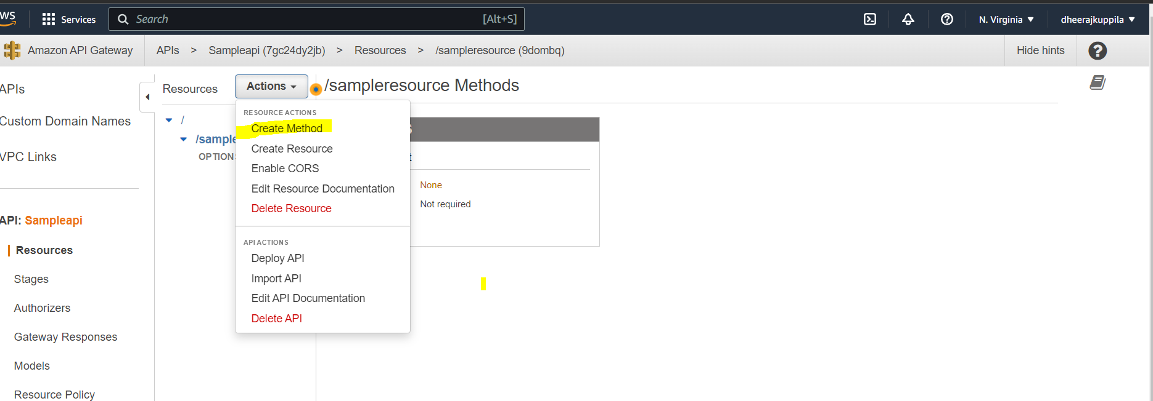

Step 7- Select Post and Press the tick mark

Step 8- Select The lambda function which you want to connect and press save

Step 9- Now from Actions select Deploy Api

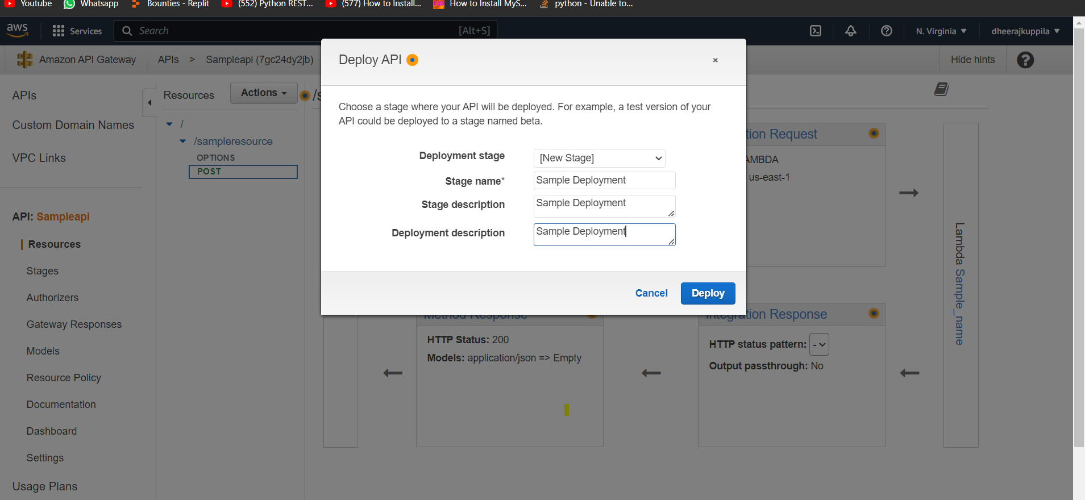

Step 10- A url is displayed which can be used in Postman to access the api

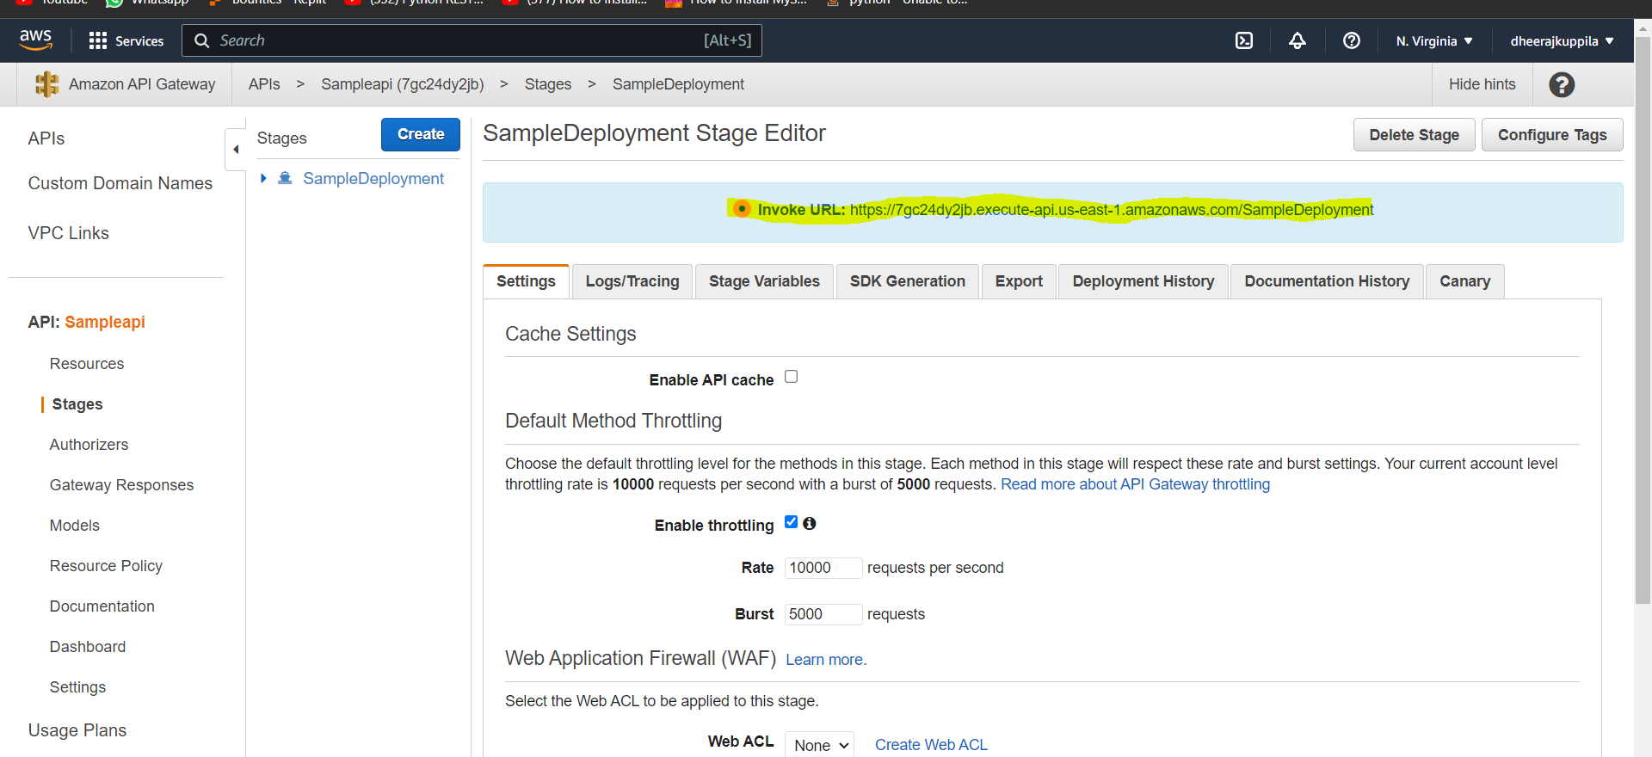

Accessing from Postman

Create a collection and add a post Request using the below post body.

Post Body-

{

    "sourceText": "The bone of contention right now is how to make plenty money."

}

The Endpoint in aws must be appended with the Resource name

Detailed Steps-https://www.freecodecamp.org/Crnews/how-to-setup-a-basic-serverless-backend-with-aws-lambda-and-api-gateway/